Particular | Details
Project Name | AI-Enabled Student Admission System
Team ID | SWITD-2026-9625
Submission Date | 26-06-2026
Maximum Marks | 100 Marks

Introduction
The Lightning App Development phase focuses on creating a user-friendly interface for the AI-Enabled Student Admission System using Salesforce Lightning Experience. Salesforce Lightning provides a modern, responsive, and customizable user interface that allows users to access records, applications, reports, and automation features efficiently.
In this phase, a dedicated Lightning Application named "AI-Enabled Student Admissions & Support Management System" was created. The application provides a centralized workspace for admission counselors, admission managers, and administrators to manage student records, courses, enrollments, opportunities, and AI-powered insights.
The Lightning App was configured with required objects, navigation items, user access permissions, and customized page layouts to improve productivity and simplify daily admission operations.

3.2 Creating Lightning Application
Objective
To create a dedicated Salesforce Lightning application for managing student admission activities and providing easy access to important records.

Steps Performed
- Navigate to:
Setup → App Manager
- Click on:
New Lightning App
- Enter Application Name:
AI-Enabled Student Admissions & Support Management System
- Upload an application image related to student admission management.
- Configure App Options with default settings.
- Configure Utility Items.
- Add required navigation items:
- Account
- Contact
- Student_Enrollment__c
- Course__c
- Opportunity
- Assign application access to:
- System Administrator
- Click:
Save & Finish

📷 Figure 3.1 – Lightning App Creation
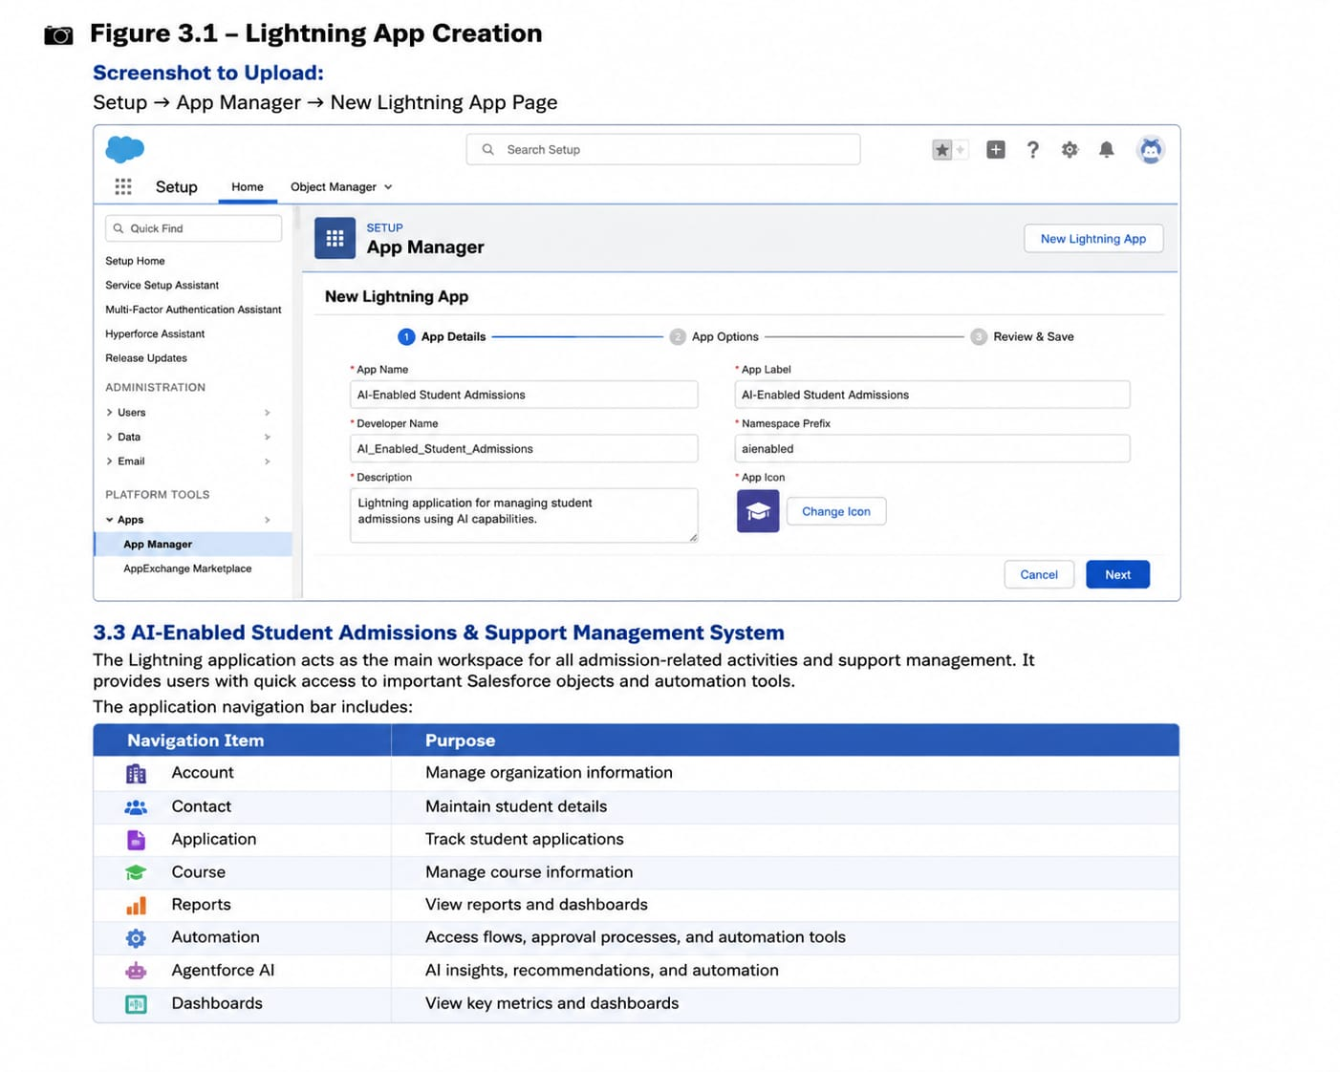

3.3 AI-Enabled Student Admissions & Support Management System App
The Lightning application acts as the main workspace for all admission-related activities. It provides users with quick access to important Salesforce objects and automation features.
The application navigation bar includes:
Navigation Item | Purpose
Account | Manage organization information
Contact | Maintain student details
Course | Manage available courses
Student Enrollment | Track student admission records
Opportunity | Manage admission opportunities

Benefits of Lightning App
- Centralized admission management
- Easy navigation
- Improved user productivity
- Role-based access
- Better user experience
- Quick access to student information

📷 Figure 3.2 – Lightning Application Home Page
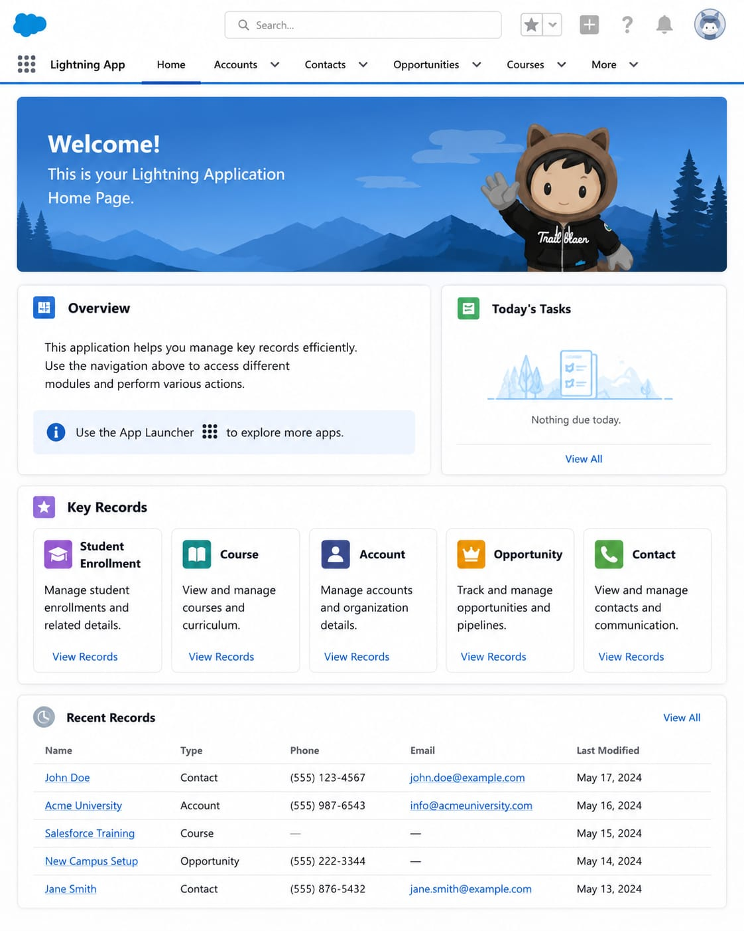

3.4 Page Layout Configuration
Introduction
Page layouts control the organization and visibility of fields, sections, buttons, and related lists displayed on Salesforce record pages. In this project, page layouts were customized to provide users with relevant information while reducing unnecessary complexity.
The page layouts were modified for:
- Student Enrollment Object
- Course Object
- Account Object
- Opportunity Object
- Contact Object

3.5 Student Enrollment Page Layout Configuration
The Student Enrollment page layout was customized to display important admission-related information.
Fields Added
- Student
- Course
- Enrollment Date
- Discount Percentage
- Final Payable Amount
- Enrollment Status
- Approval Status
- Payment Status
- AI Priority Score
- Risk Level
Purpose
This layout provides counselors and managers with complete enrollment information including AI-generated insights and approval status.

📷 Figure 3.3 – Student Enrollment Page Layout
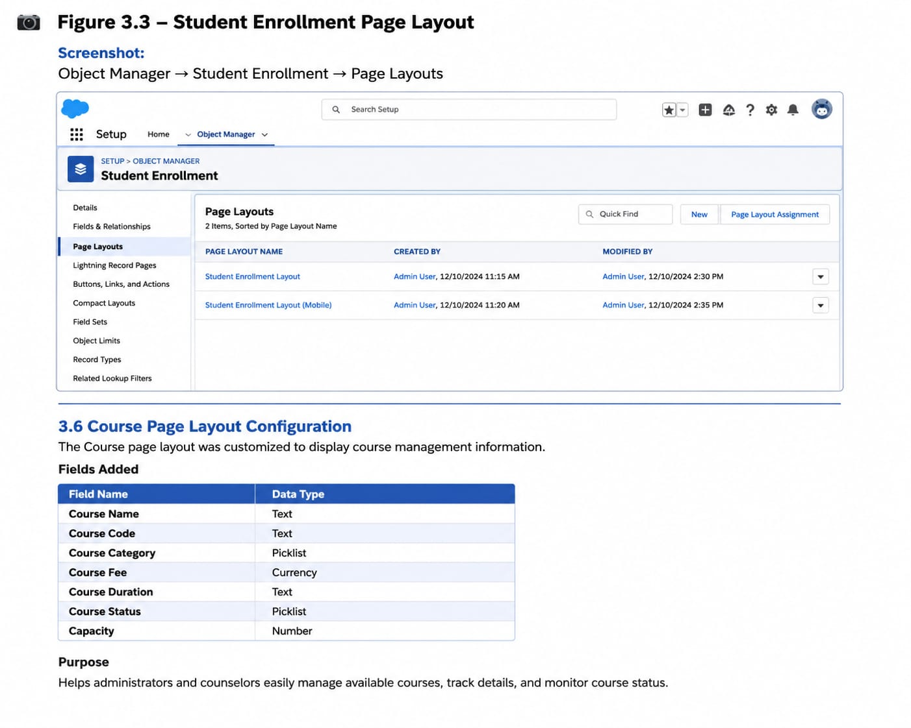

3.6 Course Page Layout Configuration
The Course page layout was customized to display course management information.
Fields Added
- Course Name
- Course Code
- Course Category
- Course Fee
- Course Duration
- Course Status
- Capacity
Purpose
Helps administrators and counselors easily manage available courses.

📷 Figure 3.4 – Course Page Layout
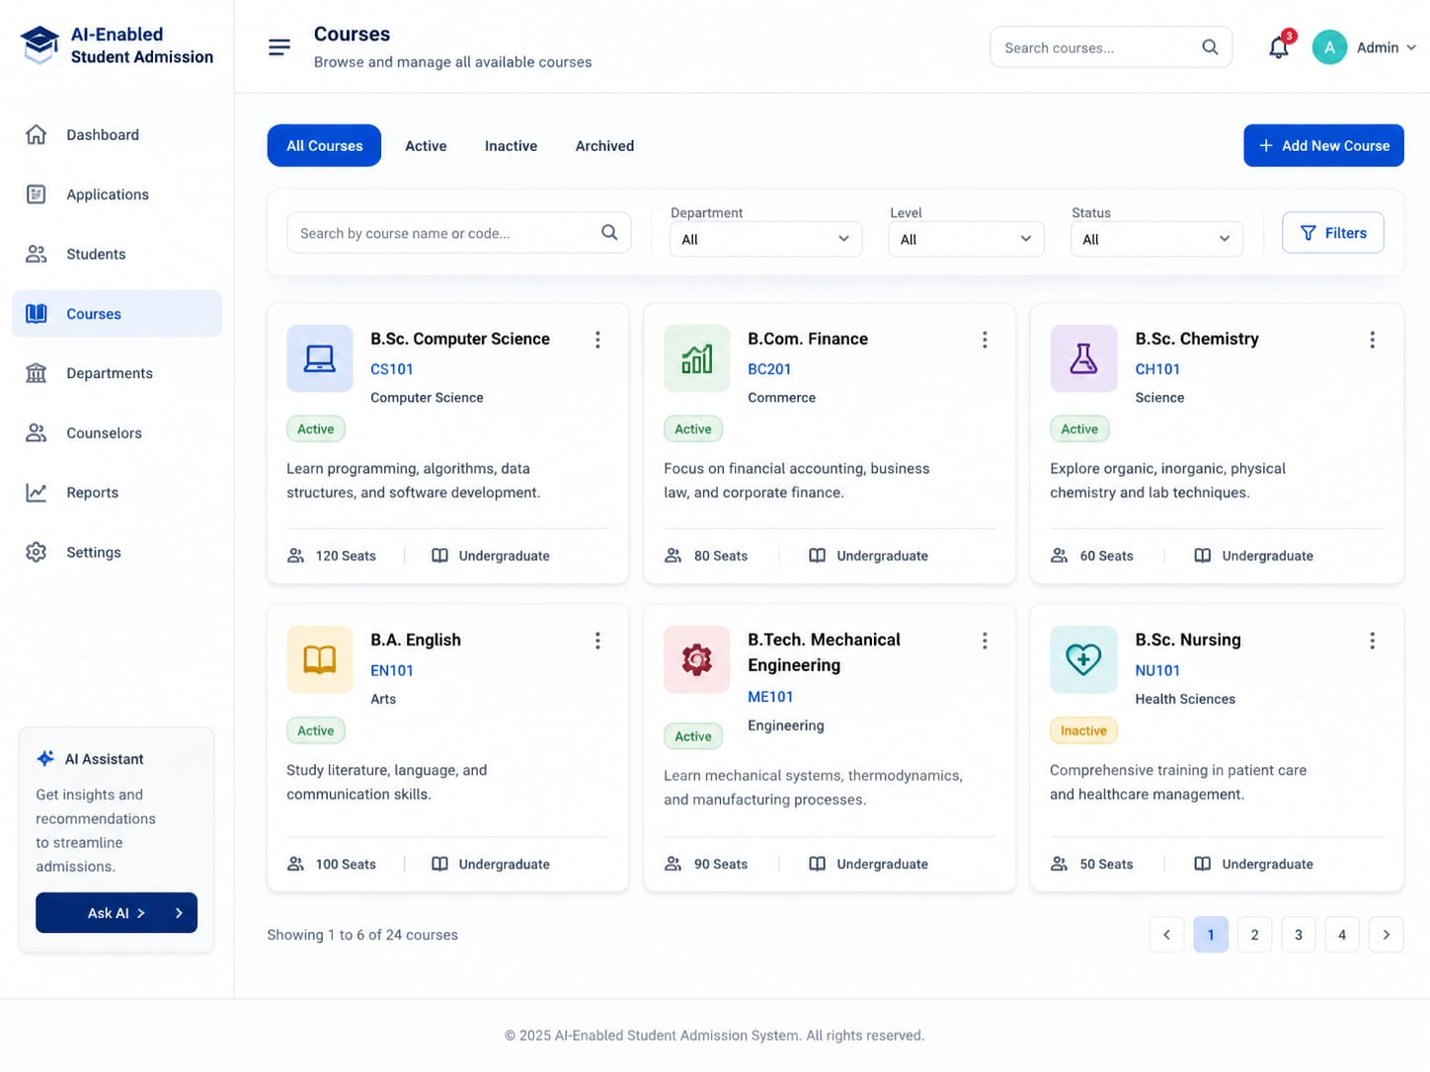

3.7 Account Page Layout Configuration
The Account page layout was modified to organize institution-related information.
Purpose
Provides structured access to account records and related admission information.

📷 Figure 3.5 – Account Page Layout
Insert Screenshot Here

3.8 Opportunity Page Layout Configuration
The Opportunity page layout was customized to support admission tracking.
Fields Added
- Admission Stage
- Expected Start Date
- Payment Status
- Counselor Assigned
- Total Course Fee
Purpose
Allows counselors to monitor student admission progress from inquiry to enrollment.

📷 Figure 3.6 – Opportunity Page Layout
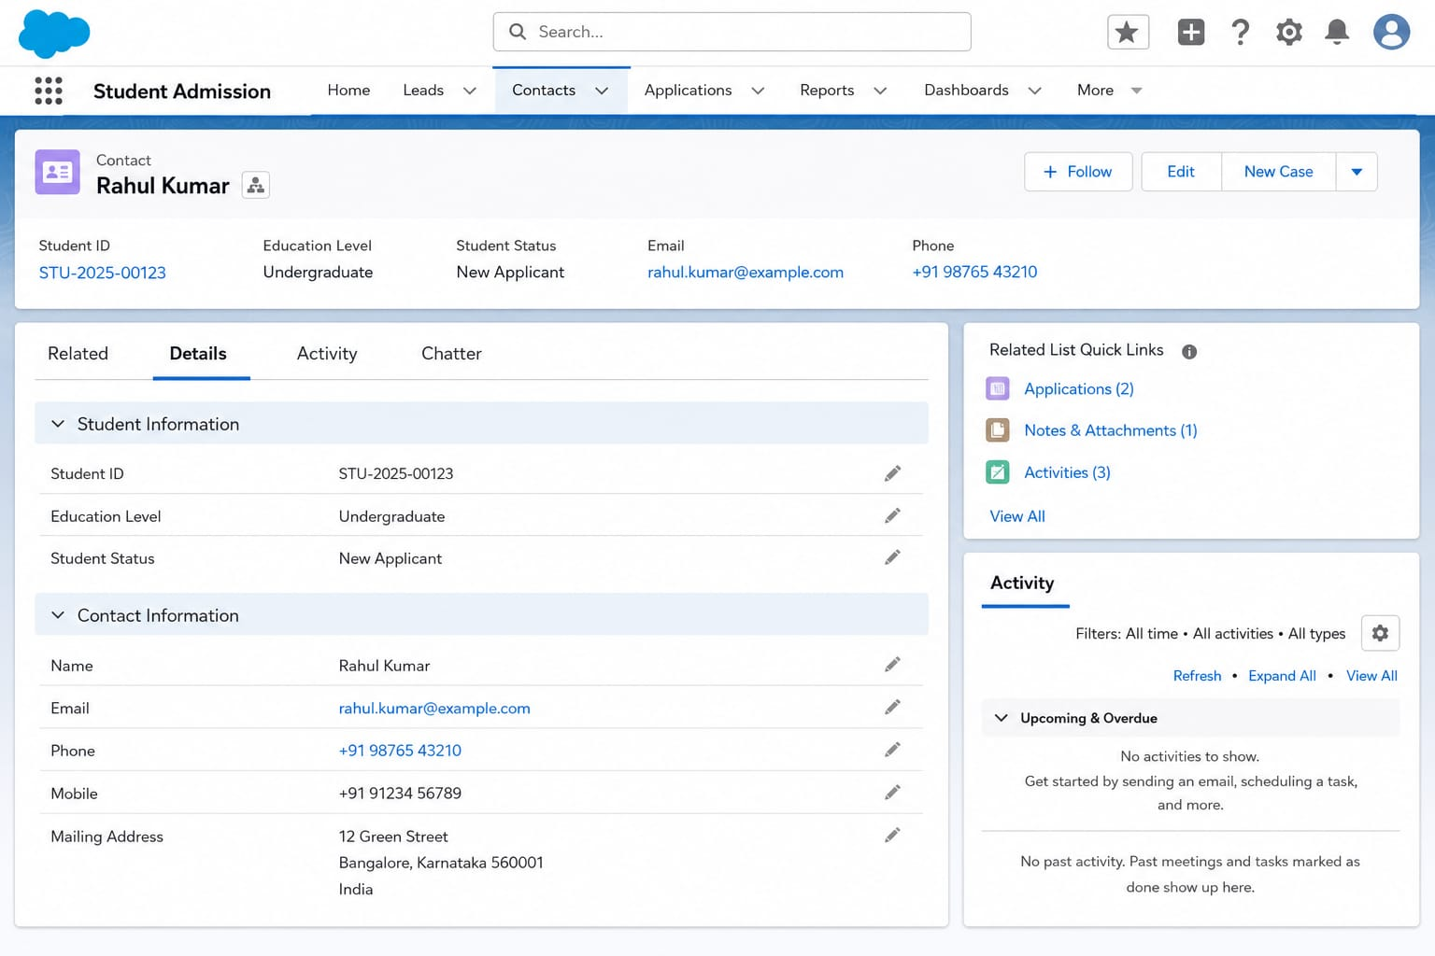

3.9 Contact Page Layout Configuration
The Contact object was customized to represent student information.
Fields Added
- Student ID
- Education Level
- Student Status
Purpose
Provides complete student profile information for admission processing.

📷 Figure 3.7 – Contact Page Layout
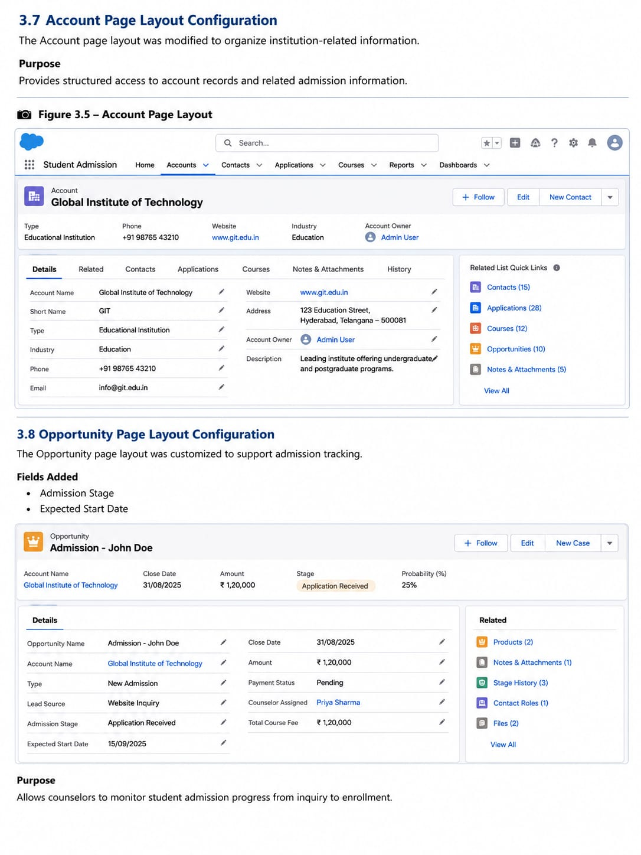
📷 Figure 3.8 – Dynamic Forms Configuration
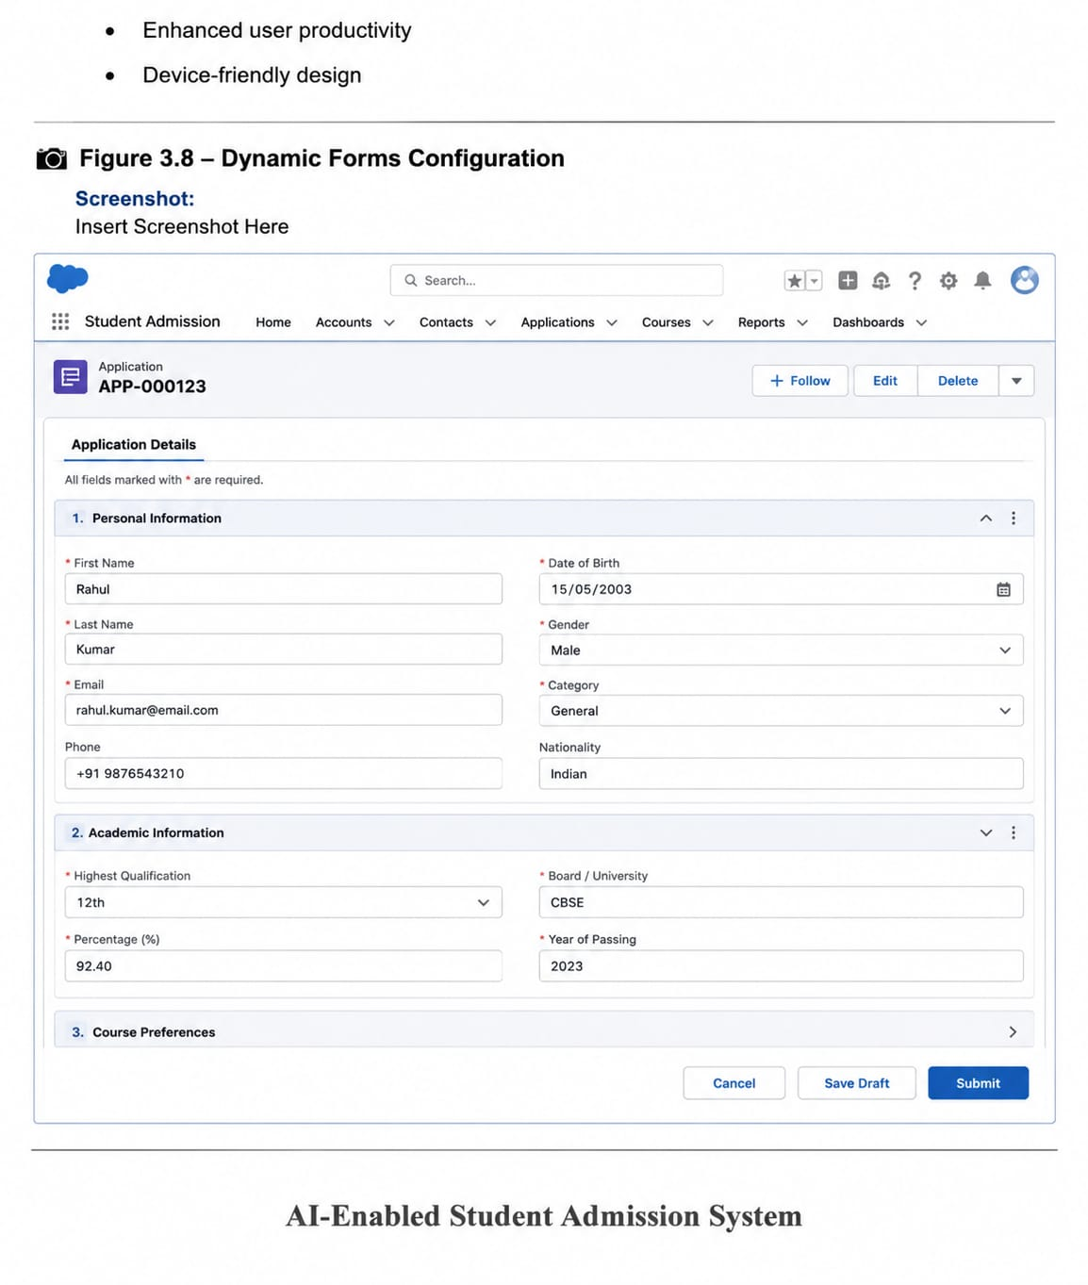
Security, Data Quality and Access Management

4.1 Introduction
The Security, Data Quality, and Access Management phase focuses on maintaining secure access, accurate data, and controlled visibility within the AI-Enabled Student Admission System.
In Salesforce, security is implemented at different levels including organization, object, field, and record levels. This phase ensures that admission counselors, admission managers, and administrators can access only the required information based on their responsibilities.
Data quality is also a critical part of the admission system because duplicate student records or duplicate enrollment records can affect:
- AI priority scoring
- Admission risk analysis
- Agentforce recommendations
- Approval decisions
- Reports and dashboards
To maintain accurate and reliable data, Salesforce Matching Rules and Duplicate Rules were configured.
4.2 Objectives of Security and Data Management
The main objectives of this phase are:
- Prevent duplicate student records
- Prevent duplicate enrollment records
- Maintain clean and reliable admission data
- Implement role-based access control
- Provide secure access to users
- Protect AI-related information
- Improve reporting accuracy

Team Information
Team ID : SWTID-2026-9625
Team Size : 5
Team Leader : Gayathri Pemmanaboyidi
Team member : Anitha Kumari Seekolu
Team member : Aditya Vardhan Katta
Team member : Jaswanth Srikar Addanki
Team member : Sontenam Santosh Venkat Charan

S.No | Role | Full Name | Email ID
1 | Team Lead | Gayathri Pemmanaboyidi | gayathridevipemmanaboyidi@gmail.com
2 | Team Member | Anitha Kumari Seekolu | seekoluanitha13@gmail.com
3 | Team Member | Aditya Vardhan Katta | kattaadityavardhan@gmail.com
4 | Team Member | Jaswanth Srikar Addanki | jaswanthsrikar56@gmail.com
5 | Team Member | Sontenam Santosh Venkat Charan | ssvcharan414@gmail.com

